Frobenius norm

Intro

Frobenius norm is an extension of Euclidean norm and comes from Frobenius inner product.

See also:

My note:

Frobenius inner product.docx

Def

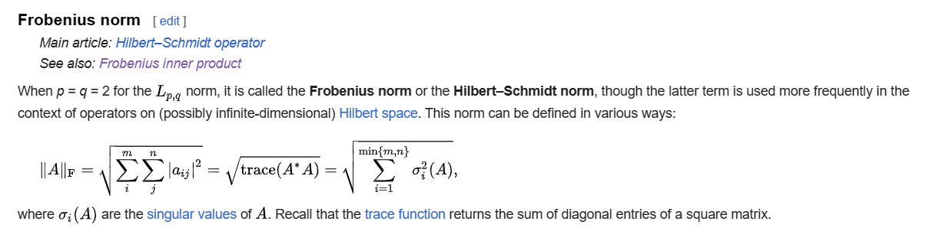

Ref

See Frobenius norm section in Wiki,

[Matrix norm - Wikipedia](https://en.wikipedia.org/wiki/Matrix_norm)